PROJECT 5-POLICY AND PRESENTATION

1.AI Identity Security Policy
Screenshot showing the AI Identity Security Policy title page and table of contents containing all three required sections.

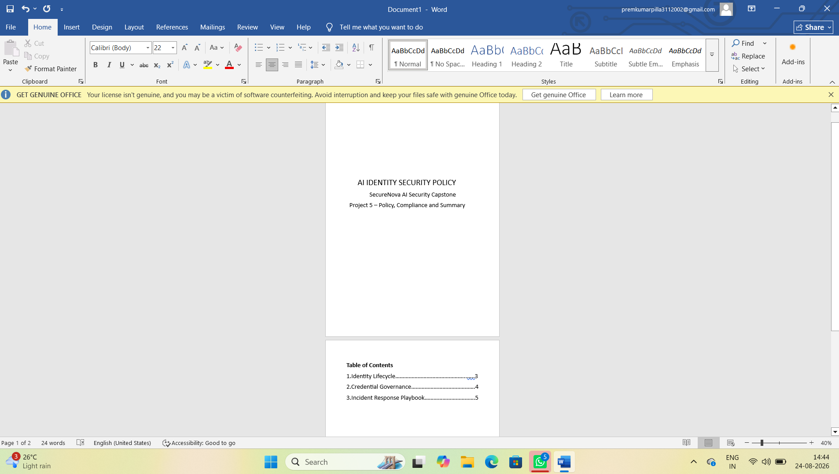

2.Incident Response (IR) Playbook:
Screenshot showing the Incident Response Playbook with a completed scenario including detection signals and containment steps.

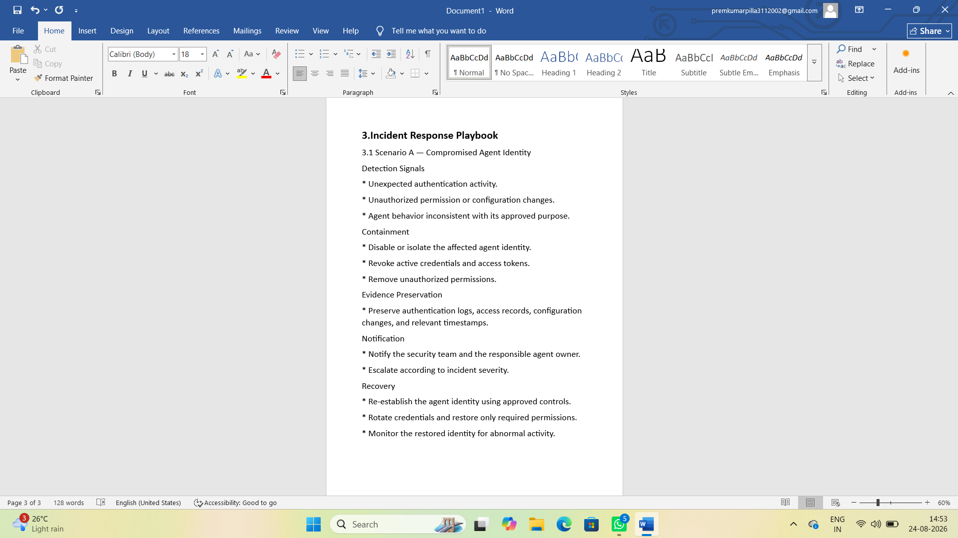

3. NIST AI RMF Mapping:
Screenshot showing the NIST AI RMF compliance mapping with the four functions — Govern, Map, Measure and Manage — mapped to supporting evidence.

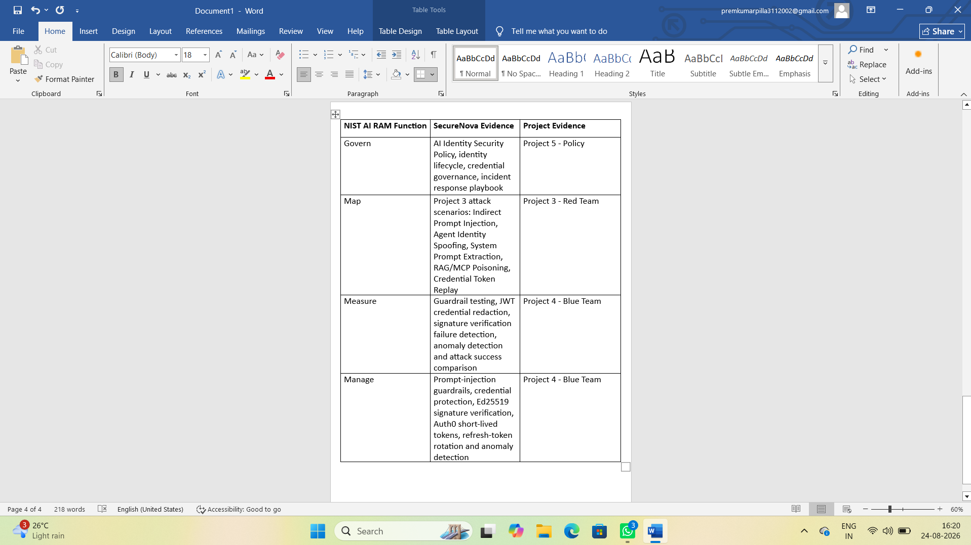

4. OWASP LLM Top 10 Mapping:
Screenshot showing the OWASP LLM Top 10 mapping with relevant categories connected to Project 3 attacks and Project 4 controls.

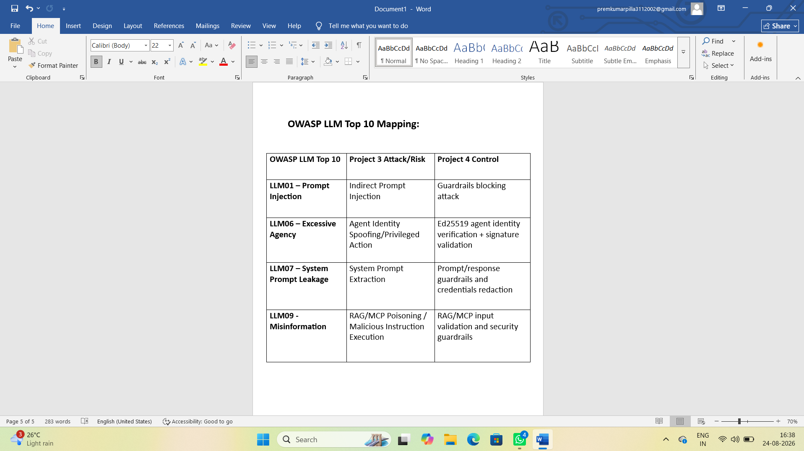

5. GitHub Repository:
Screenshot showing the GitHub repository page with all five project folders visible.

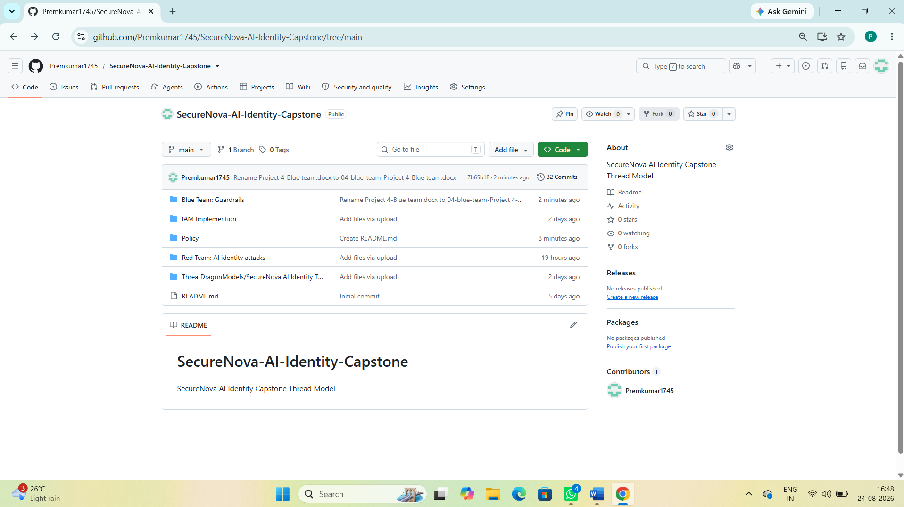

6.GitHub Commit History:
Screenshot showing the GitHub commit/contributor history demonstrating contributions across the project days.

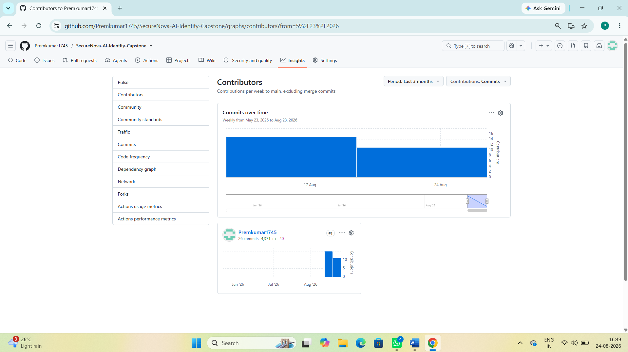

7.Risk Priority Matrix:
Screenshot showing the Risk Priority Matrix with the identified findings plotted and their CVSS scores labelled.

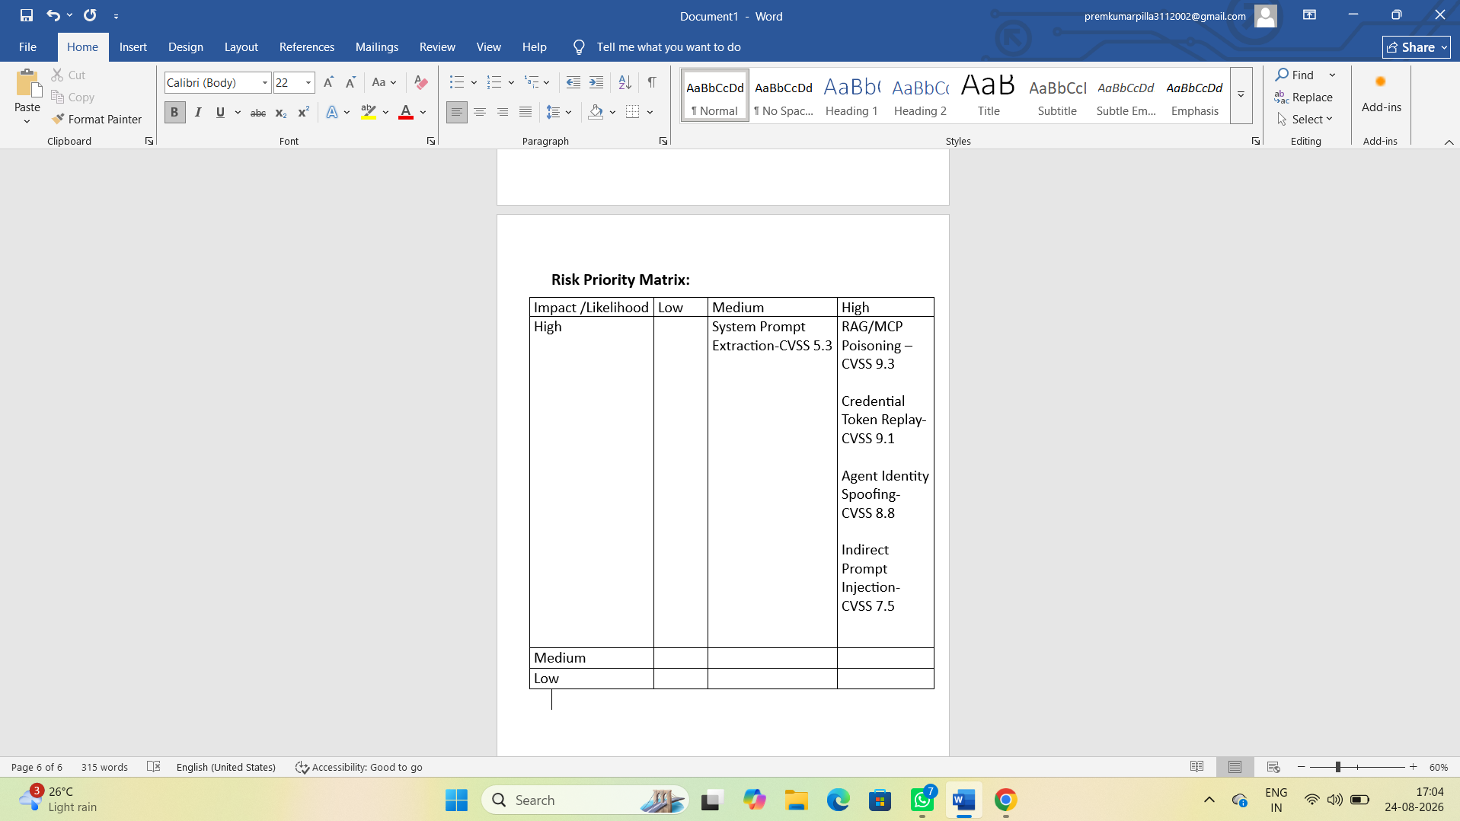

8.Top 5 Security Recommendations:
Screenshot showing the five security recommendations with effort estimates and business rationale.

